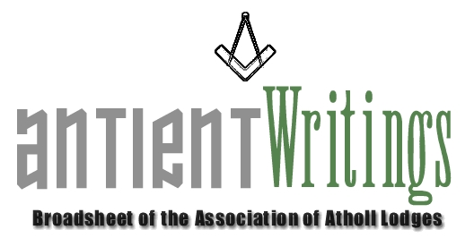

1st Edition, 2006

President RW Bro. Russell Race PJGW

The Association has a new President. Russell is the Deputy Metropolitan Grand Master and looks forward to a full involvement and helping the Association over the forthcoming years. Also V.W.Bro. John Hamill, Director of Communications, UGLE, and, R.W.Bro. Afeef Lazarus, District Grand Master for Jamaica and the Caymen Islands, have agreed to serve as Vice Presidents. All are very welcome.

Website http://www.antients.com

The web-site is now fully functioning and everyone is encouraged to use it. There is an events and news facility and future plans to build an exclusive site for Atholl Lodges with links to the main site. Any items can be included by emailing them to the Webmaster, Neil, via the click-on button on the site.

Joining or Renewing - Annual Subscriptions Reduced for 2006 - 2007

If you and your lodge would like to enjoy the benefits of the Association by subscribing please contact Rod Letherby on 020 8690 6749 or email roderick@rletherby.freeserve.co.uk . The subscriptions have been reduced for two years [Full & Associate £15 - Affiliate £10 Lodge & £5 Individual] to help with financial pressures currently bearing on lodges. Lodges may notate their summons: A Member of the Association of Atholl Lodges

Regions Required

Any area with a cluster of Atholls who wish to make themselves as a Region [with a key hub], to encourage mutual interest and fraternal support between Atholls, contact the Secretary who will be pleased to discuss the possibilities.
If you are interested in joining the Executive Committee, which meets 3 times a year in London, please make contact.

Dermott 2006

2006 is the 250th anniversary of the publication of Laurence Dermott’s constitution Ahiman Rezon [1756]. The Association has planned an ‘event year’ with displays and talks about this unsung collosus of Antient freemasonry. Many VIPs have agreed to attend these events. The Library and Museum at Great Queen Street are mounting a Dermott display for the second half of the year. The programme is:

TUE MAR 14TH 2006 Event in the North East – Hull – [3.30pm-Evening]
SAT APRIL 29TH 2006 …. Event in the South - Sindlesham – Displays&Luncheon [10am-3pm]
SAT JULY 22ND 2006….. London Event - Displays & Luncheon - Gt Queen St [10am-4pm]
SAT SEPT 23RD 2006…..Event in the North - Stockport – Cheshire [10am-3pm]
THUR DEC 13TH 2006…...Informal Event to close London Library&Museum Display [3pm]

In addition there will be some informal visits by invitation to lodges to give talks and spread the word about the Antients and their lost emissary, Dermott. A 40 page A4 illustrated book has been published to support this special year. The book ‘a brothers assistant’ is available at £5 [Inc. P & P £6 UK Mainland] from the Secretary. See Flyer.
All information, including costs, and full details are on the web site or can be obtained from the Secretary.
Your support is needed to make this a truly memorable year! A flyer for the main London event is with this mailing.

Would Secretaries and Representatives photocopy and distribute as widely as possible

Paul Gardner
39 Wentworth Drive, Bedford, BEDS, MK41 8QA
012340261584 secretary @antients.com

